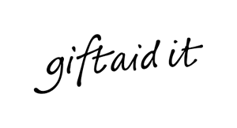
Gift Aid Declaration

I want the 3rd Hayling Scout Group to treat all payments I make on or after today in respect of the membership subscription for the Group as Gift Aid donations.

Scout’s name _____________________________________

Donor’s details
Title: _______________ Initial(s): _______________Surname: ______________________________________
Home address: ___________________________________________________________________________
________________________________________________________________________________________
Postcode:_____________________________________ Date: ____________________________________
Signature: _______________________________________
I confirm I have paid or will pay an amount of Income Tax and/or Capital Gains Tax for each tax year (6 April to 5 April) that is at least equal to the amount of tax all the charities or Community Amateur Sports Clubs (CASCs), that I donate to, will reclaim on my gifts for that tax year. I understand that other taxes such as VAT and Council Tax do not qualify. I understand the charity will reclaim 25p of tax on every £1 that I give on or after 6 April 2017.

Please notify us if you:
- Want to cancel this declaration.
- Change your name or home address.
- No longer pay sufficient tax on your income and/or capital gains.
Tax claimed by The 3rd Hayling Island Scout Group
  - The 3rd Hayling Scout Group will reclaim 25p of tax on every £1 you give on or after 6 April 2017.

If you pay income tax at the higher rate, you must include all your Gift Aid donations on your Self Assessment tax return if you want to receive the additional tax relief due to you.

PLEASE COMPLETE THIS FORM AND RETURN IT TO YOUR LEADER

